

**BBA 4th Sem**

**2023-2024**

**Course Project**

**Submitted To:** Prof. Ankur Kumar Rastogi

**Submitted By:** Shankh Bansal (AU22C1013)

**About The Company:**

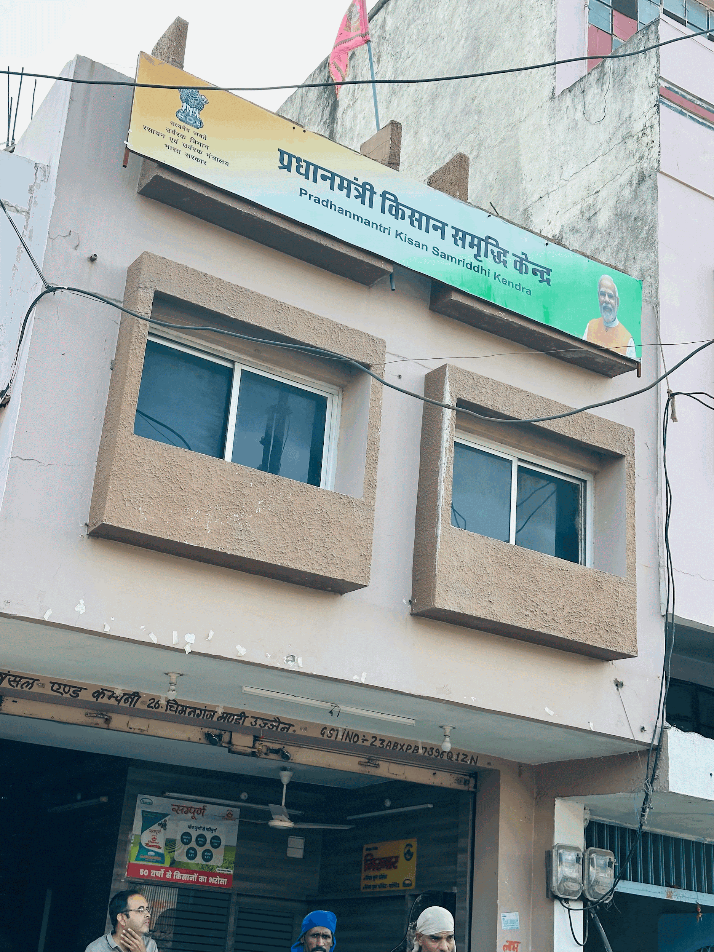

**Established in 1980, Bansal & Company has become more than just another agricultural supply store – it is an important pillar for farmers. Driven by a clear vision to empower local agriculture, Bansal & Company offers a multi-faceted range of products that extends beyond just animal feed.**

**The secret of success for Bansal & Company:**

* **Diversity:** Unlike conventional stores, Bansal & Company caters to agricultural needs. Their range includes tudki and churi, Cattle Feed which may refer to specific regional agricultural practices. This comprehensive approach ensures that farmers can access everything they need under one roof, streamlining their operations and saving valuable time.
* **High yield:** Bansal & Company understand the significant impact of supply chain quality on farm productivity. They strategically focus on factors that directly contribute to increased yields and overall farm efficiency. This focus translates into huge benefits for farmers, enabling them to maximise their yields and achieve greater quality crops with high yield.
* **Preservation of Quality Vegetables:** By providing high supply standards and expert guidance (which can be determined by their longevity and market share), Bansal & Company empowers farmers to grow healthy crops in which it retains its unique character. Not only does this help consumers with better crops, but it also means potentially higher profits for farmers due to better quality crops.
* **Market Dominance:** The high market capitalization of Bansal & Company indicates a dominant position in their sector. This probably reflects a well-deserved reputation for high quality products, reliable service and competitive prices. Farmers have come to rely on Bansal & Company as a reliable partner in their agricultural business as they have been established in 1980 and since that they are serving best quality feeds to the farmers.

**Bansal & Company is not just a normal shop, it has been a pillar of the farming community for more than four decades. Established in the 1980s, they have seen the business grow and understand the needs of farmers. With a commitment to serve the farming community and a commitment to innovation, Bansal & Company make sure that they serve the farmers in the best way possible which can also be witnessed by their repeat customer rates.**

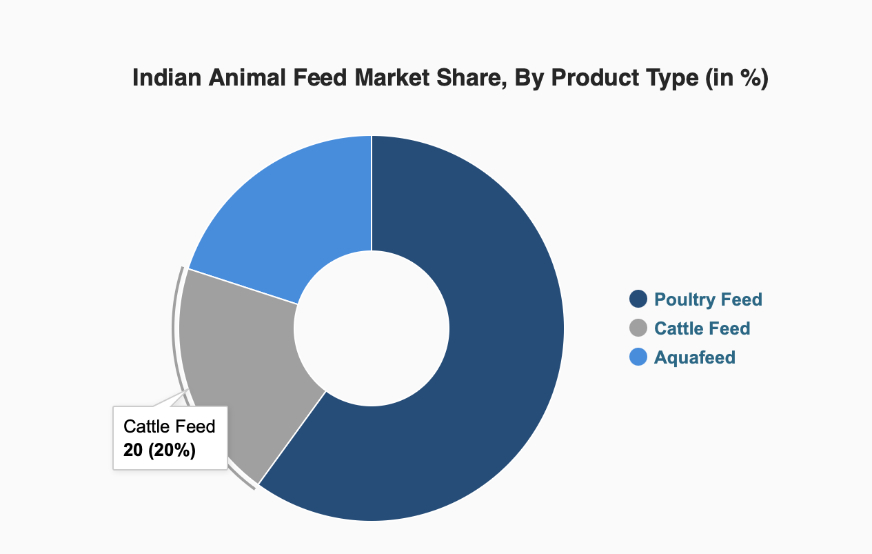

**Global Market Size of Animal feed:**

**Global Cattle Feed Market size was valued at USD 76.267** billion **in 2021 and is poised to grow from USD 79.2 billion in 2022 to USD 104.18 billion by 2030, growing at a CAGR of 3.92% in the forecast period (2023-2030).**

According to a report, India, Brazil and China are the three largest cattle producers in the world, amassing about 300 million cattle in their respective countries, followed by Africa with 200 million although the Americans only have 10 millions do . These factors drive the growth of the market. A balanced animal feed is essential for the success of the intensive livestock development programs adopted by the State Government. It looks at a picture of the future prospects of this industry in the market. Farmers will be encouraged to use mixed feeds to increase the growth of their animals due to the high meat yield benefits. Accordingly, more investment is expected in the animal feed industry in the near future.

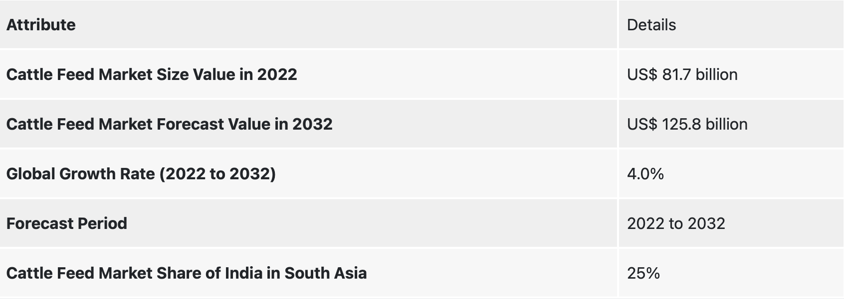

**Market Size of Germany:**

**The Germany Compound Feed Market size is estimated at USD 15.77 billion in 2024, and is expected to reach USD 18.37 billion by 2029, growing at a CAGR of 3.10% during the forecast period (2024-2029).**

* Germany is known as the European Union's largest dairy producer, yet it has undergone rapid and far-reaching structural changes in recent decades. Germany witnessed a vigorous consolidation process in which the number of farms has fallen significantly, the remaining farms have grown, and overall milk output has increased due to increasing milk production per cow. German dairy farmers also had to contend with rising production costs.
* Germany is home to approximately 12.9 million cattle, mostly dairy cows. There are 4.2 million dairy cows and 0.7 million sucker cows. According to the European Union's statistics, Germany is the country with the largest herd of dairy cattle and the second largest population of cattle.
* It is estimated that the German animal feed market will reach $15.429 billion by 2024. With rising consumer health concerns and expanding dietary practices in raw and processed meats, Germany is one of Europe's top markets for animal feed. High standards of performance and quality testing are essential for sustainable breeding programs and effective farm management. It is estimated that around 2.6 million cows and 3.5 million cattle are registered for milking.
* A total of approximately 10.6 million Euros has been generated from cattle production in Germany, contributing approximately 25 percent to the agricultural output of the country. Bovine semen is another leading export of Germany, which is the world’s largest exporter of breeding cattle. Thus all these factors will further grow the market for cattle feed in this region.

**Market Size of USA:**

**In North America, the cattle population was 140.8 million heads in 2021. The increasing population creates an increasing demand for cattle feed.**

* In North America, the United States is the largest producer of animal feed including cattle feed, and globally, the second largest producer of cattle feed after China due to the significant population and demand of its livestock industry, the United States is one of the largest cattle feed exporters.
* According to ITC, in 2021, the United States contributed 8.9% of the total feed export. The region is witnessing growth due to a free-trade agreement between the United States, Canada and Mexico as these are the countries which accounted for more than 90% of the feed production in North America.
* The region has many of the global leading animal feed producers. The prominent feed manufacturers in the country include Cargill, Land O'Lakes, Alltech, ADM Alliance Nutrition, Perdue Farms, J.D. Heiskell & Co. Kent Nutrition Group, Hi-Pro Feeds, and Southern States Coop.
* Therefore, owing to factors such as free-trade agreement, high cattle population and presence of leading feed manufacturers for exporting and domestic consumption has helped the North America region to be a largest region during the forecasted period.

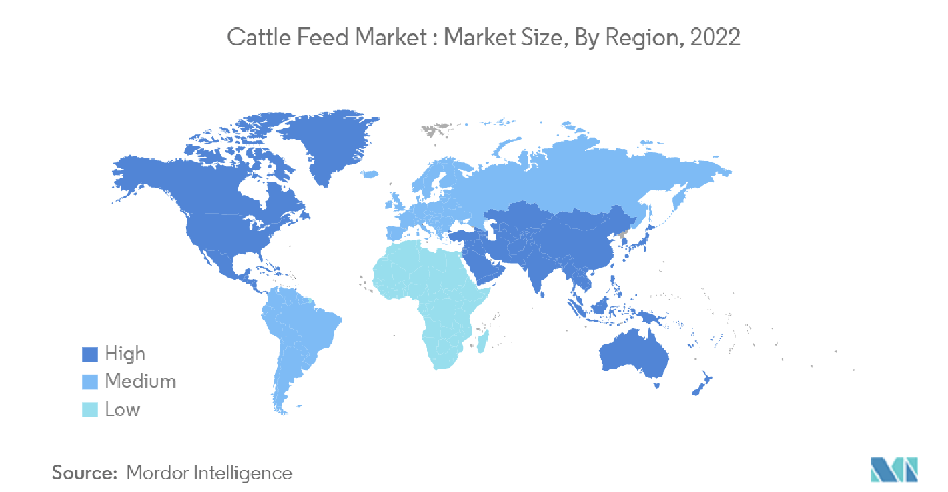

**Why German is best for exports:**

There are 4.2 million dairy cows and 0.7 million suckler cows. According to the European Union’s statistics, Germany is the country with the largest herd of dairy cattle and the second largest population of cattle. It is estimated that the German animal feed market will reach $15.429 billion by 2024. With rising consumer health concerns and expanding dietary practices in raw and processed meats, Germany is one of Europe’s top markets for animal feed.

**Competition in German Market:**

* Deutsche Tiernahrung Cremer
* Nestle (Purina-Pet Feed)
* ForFarmers HaGe Kiel
* Broring
* Agravis Raiffeisen AG
* GS Agri
* Fleming & Wendeln
* Rothkotter
* Mars, etc.

**Economic Stability of Germany:**

**The economy of** [**Germany**](https://en.wikipedia.org/wiki/Germany) **is a** [**highly developed**](https://en.wikipedia.org/wiki/Developed_country)[**social market economy**](https://en.wikipedia.org/wiki/Social_market_economy)**.It has the largest national economy in** [**Europe**](https://en.wikipedia.org/wiki/Europe)**, the** [**third-largest by nominal GDP**](https://en.wikipedia.org/wiki/List_of_countries_by_GDP_(nominal)) **in the world, and** [**fifth by GDP (PPP)**](https://en.wikipedia.org/wiki/List_of_countries_by_GDP_(PPP))**. Due to a volatile currency** [**exchange rate**](https://en.wikipedia.org/wiki/Exchange_rate)**, Germany's GDP as measured in dollars fluctuates sharply. In 2017, the country accounted for 28% of the euro area economy according to the** [**International Monetary Fund**](https://en.wikipedia.org/wiki/International_Monetary_Fund) **(IMF).Germany is a founding member of the** [**European Union**](https://en.wikipedia.org/wiki/European_Union) **and the** [**eurozone**](https://en.wikipedia.org/wiki/Eurozone)**.**

* In 2016, Germany recorded the highest [trade surplus](https://en.wikipedia.org/wiki/Balance_of_trade) in the world, worth $310 billion. This economic result made it the biggest capital exporter globally.Germany is [one of the largest exporters globally](https://en.wikipedia.org/wiki/List_of_countries_by_exports) with $1.81 trillion worth of goods and services exported in 2019.The [service sector](https://en.wikipedia.org/wiki/Tertiary_sector_of_the_economy) contributes around 70% of the total GDP, industry 29.1%, and agriculture 0.9%. Exports accounted for 50.3% of national output.

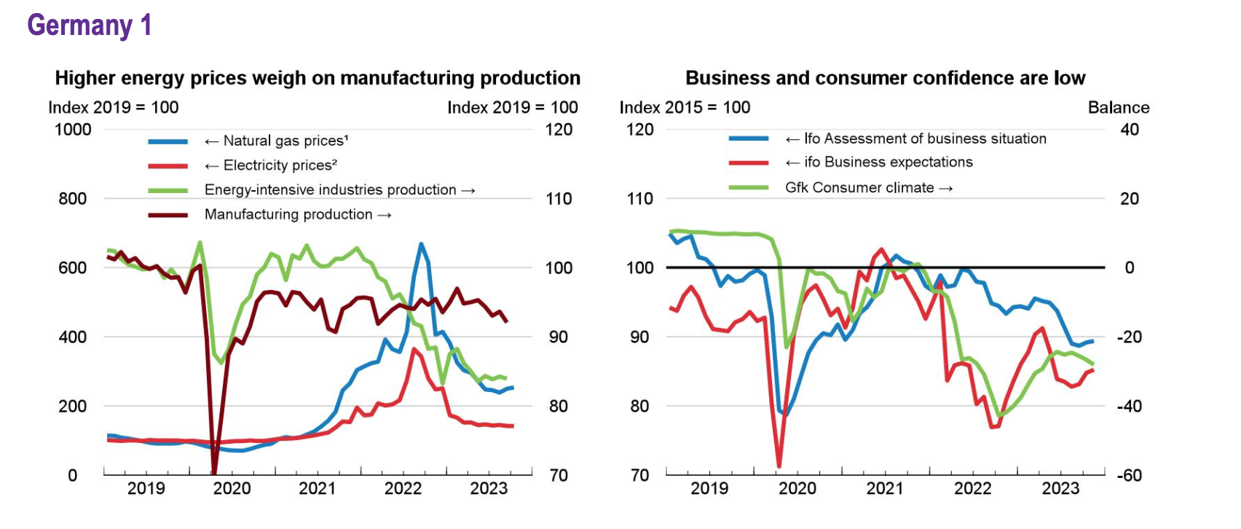

**Cultural nuances in Germany:**

German people tend to be thrifty, be sensible, and respect one another’s privacy, and they typically respect the structure and laws of society to an above-average degree. There is no place where this sense of ‘order’ is more apparent than in German business culture. Traditionally, German people tie a lot of importance to notions of family and community.

**legal environment of Germany:**

Germany's legal system is based on civil law. It consists of a legislature and an independent judiciary. Legislative power resides at both the federal (Bund) and the state (Land) level. The Constitution presumes that all legislative power remains at the state level unless otherwise provided.

Germany does not have one central supervisory authority for data protection law but authorities in each of the sixteen German federal states (Länder) that are competent for the public and the private sector in the respective state.

BaFin operates in the public interest. Its primary objective is to ensure the proper functioning, stability and integrity of the German financial system.

**Overview of german animal Feed Market**

Increasing awareness about the contribution of animal feed in improving the diets of farm animals and expanding the livestock population is leading to higher demand for animal feed in Germany. According to TechSci Research report, “Germany Animal Feed Market By Type, By Region, Competition, Forecast & Opportunities, 2025”, Germany animal feed market was valued at around $ 19 billion in 2019 and is forecast to cross $ 23 billion by 2025 due to increasing demand for chicken, beef and other meat products, resulting in driving the livestock population in Germany.

The animal feed industry has faced a number of challenges in recent years. The volatility of raw material prices, the decline in livestock numbers and the ongoing cost pressure have caused problems for market participants, as has the drought in the summer of 2018. This led to a shortage of supply, while demand from farmers increased. At the same time, however, feed consumption per livestock increased, as milk, laying and meat yields were increased by customers. Apart from volatile commodity prices, the coronavirus crisis only had a minor impact on the industry. This results in average annual sales growth of 2.6% for the entire period from 2018 to 2023. In the current year, industry turnover is expected to increase by 1.9% year-on-year to €10.2 billion.

**Market Trend of germany:**

The escalating demand for livestock products in Germany, driven by factors such as population growth and changing dietary preferences, is significantly increasing the demand for animal feed. As consumers continue to incorporate meat, dairy, and other livestock-derived products into their diets, the livestock industry is experiencing a parallel surge in production. This heightened livestock production necessitates a corresponding rise in the supply of high-quality animal feed to ensure the health, growth, and productivity of the animals. Farmers and livestock producers are actively seeking reliable and nutritionally balanced feed options to meet the increased demands of a growing population.

The surge in livestock production not only reflects consumer preferences but also underscores the critical role of the animal feed industry in supporting the agricultural supply chain. The increasing demand for meat and dairy products places additional pressure on farmers to enhance their livestock's overall well-being and productivity. Consequently, businesses within the animal feed sector are presented with significant opportunities for growth and market expansion. Feed manufacturers and suppliers must adapt to this evolving landscape by focusing on innovation, sustainable sourcing practices, and efficient distribution channels to meet the rising demand for high-quality animal feed in Germany. The collaborative efforts of stakeholders throughout the agricultural value chain will be crucial in ensuring a resilient and responsive industry capable of meeting the demands of increased livestock production in the country.

**German Consumer Behaviour:**

There is currently much debate surrounding the housing systems for dairy cattle. Large farms, which represent a growing share of the dairy farms, prefer indoor housing systems whereas smaller farms concentrate on low-input systems by giving extended pasture access to milk cows. A consumer survey from 2013 with 1,009 German consumers dealt with consumers' attitudes towards outdoor and indoor systems as well as quality aspects of food. A factor and a cluster analysis are used to reduce the complexity and identify different consumer clusters.

The results give recommendations for farmers, constructors of animal sheds, agricultural technology and the processing dairy industry concerning strategic decisions.

Consumer behavior regarding pasture-raised products is largely defined through health and environmental attitudes and depends substantially on the context of a purchase decision. There are a variety of consumer groups willing to pay a premium for a pasture-raised attribute even on top of an organic price premium. Consumer knowledge of the subject is rather low and confusion exists regarding the terminology: consumers often mistake the production system behind pasture-raised products for organic or conventional. This calls for communication of the environmental and social benefits of pasture-based production and the importance of individual food choices. This article is the first to review scientific consumer studies on perceptions, preferences, behavior regarding and willingness to pay for pasture-raised products. Further research, especially research based on real market data, is recommended to explore the effect of specific environmental attributes, social and personal norms, informational content, and product types on consumer preferences and willingness to pay for pasture-raised products.

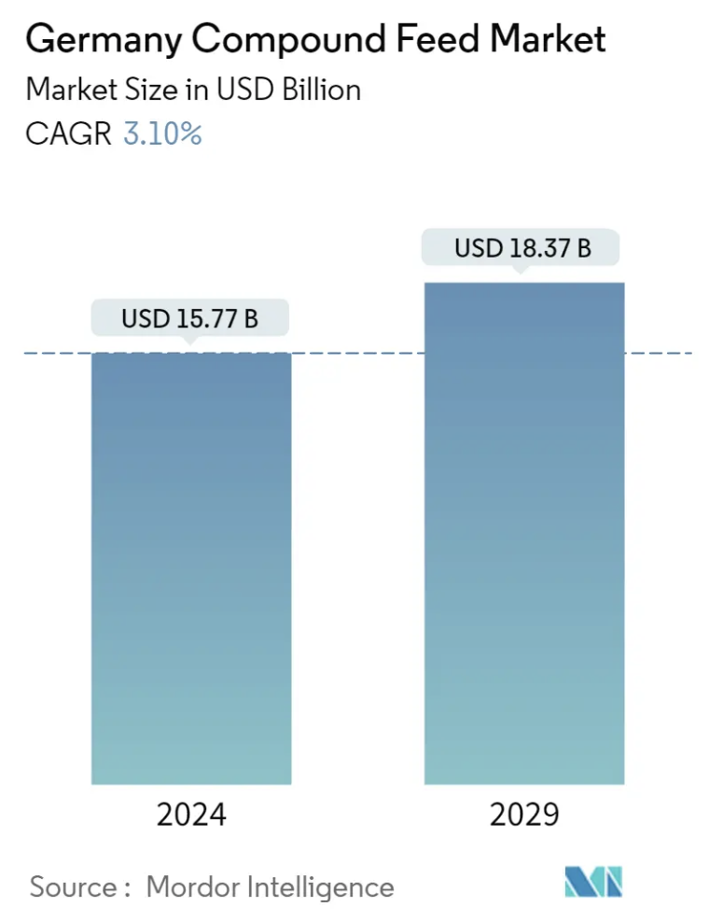

**Purchasing power of Germans:**

The current evaluation, which shows purchasing power in 2023 for the whole of Germany at Municipality level, shows the regional distribution of purchasing power.

Purchasing power is particularly high in and around the major cities. The communities with the highest purchasing power run in a crescent shape through western Germany, from Hamburg to Hanover and the Rhine region with Düsseldorf, the Rhine-Main area around Frankfurt, the Stuttgart region and the Munich area. The communities with the highest purchasing power again include Grünwald near Munich (comparative index 247.7), Wohltorf near Hamburg (205.3) and Königstein im Taunus (191.6). Residents there have around twice as much purchasing power as the national average.

The "poorest" communities include Zittau in Saxony (84.4), Wolgast in Mecklenburg-Western Pomerania (84.7) or Prenzlau in Brandenburg (85.9), all of which are located in the new federal states. However, municipalities in western Germany are also included in this group with low purchasing power. These are cities such as Giessen in Hesse (81.4) or Germersheim in Rhineland-Palatinate (84.7). Trier (85.2) or Bremerhaven (86.0) are also among the cities with low purchasing power.

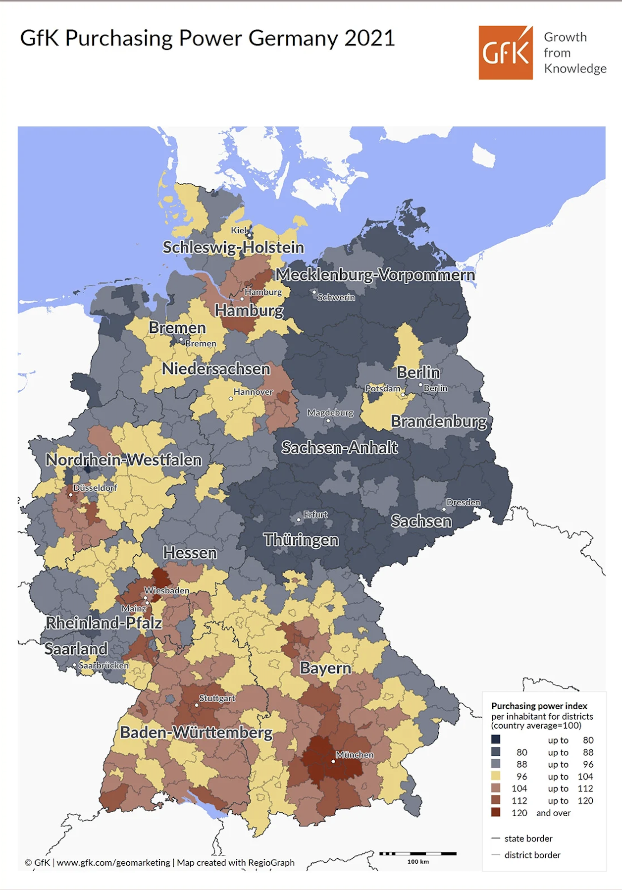

**Germany Distribution channels:**

Nijhof-Wassink is your partner for animal feed distribution across Europe. We provide the bulk transport of the dry raw materials and additives for the production of animal feed, such as proteins, milk powder, whey powder and vitamins. We also distribute loose bulk animal feed products and fertilizer from the manufacturer to the farmer. Nijhof-Wassink is a director for feed and manure transport throughout the supply chain. Our goal: optimising the entire process between producer, carrier and end user.

Nijhof-Wassink has extensive experience with the distribution of animal feeds. Depending on your needs, we can take over the planning of your animal feed transports (in its entirety or in part) from you.

In addition, you can outsource all or part of your transport to us to be even more flexible for your customers. With the assurance the fleet offers and the skilled drivers of Nijhof-Wassink you can deliver whenever your customers want it.

We aim at a full partnership in which, together with you, we work on process improvement and achieving added value. As a Fourth Party Logistics (4PL) provider we will, if desired, take the complete logistics chain off your hands.

Our planning department is manned seven days a week and 19 hours a day. To ensure the maximum availability of our fleet, we drive in double shifts per truck and our night shift loaders take care that our drivers can hit the road immediately. This way we can deliver whenever your customers want it. As an international carrier with extensive knowledge of the local markets, Nijhof-Wassink has locations throughout Europe and an extensive network of clients and strategically located transport partners. In combination with our flexibly deployable fleet, this enables us to achieve a high load factor and a minimum of empty kilometres. This way we also offer a low-cost alternative to own-account carriers.

This is what our strong network offers you:

* Optimisation of your transportation costs
* Reduction of empty kilometres
* Reduction of CO2 emissions

## **QUALITY AND SAFETY FOR YOUR BULK GOODS**

Quality, reliability and safety are paramount in our way of working. We are certified according to GMP+ B1 (storage and transhipment) and B4 (transport). Our drivers are specialists in loading, transport and unloading of animal feed and additives.

The drivers of Nijhof-Wassink are at home in the agricultural world. They are from the region, know your customer and are your and our ambassadors. And they dispose of the best equipment: modern silo trailers and specially developed compartmentalised semi-trailers in which 6 to 12 different products can be transported.

With this we bring your raw materials, animal feed and fertilizers as agreed to the place of destination: in the right quantity, according to the strictest quality requirements and just-in-time.

Nijhof-Wassink is a frontrunner in the field of safety. We work according to a strict Behaviour Based Safety (BBS) protocol. This means, among other things, that our drivers are actively trained in identifying risky situations at production sites and farmyards.

## **ASSISTANCE WITH STORAGE, TRANSHIPMENT AND PLANNING**

Nijhof-Wassink offers various storage and transhipment options for raw materials and additives for animal feed production. In our silo parks in the Netherlands your bulk goods are stored in a safe and dry environment.

### 

### **TRANSPORT MANAGEMENT SYSTEM**

With our Transport Management System (TMS) we provide planners, clients and agricultural entrepreneurs with real-time information. Data that is shared, includes order status, shipment status, expected time of arrival (ETA) and current location of the semi-trailer truck. The TMS can be linked to almost any existing planning and ordering system and is part of our innovation concept Nijhof-Wassink LIVE.

**German Competitive landscape:**

**Key Competitors of the Global Animal Feed Organic Trace Minerals Market are:**

‣ Alltech Inc

‣ Royal DSM

‣ Archer Daniels Midland Company

‣ Vamso Biotec Pvt. Ltd.

‣ Novus International Inc.

‣ Pancosma SA

‣ Cargill

‣ Biochem

‣ Nutreco N.V.

**Entry Strategies for licensing:**

**Pros:**

* **Quality & Trust:** Licences often ensure high-quality feed, enhancing brand reputation and attracting premium markets.
* **Wider Reach:** Compliance can open doors to partnerships with large farms and distributors.

**Cons:**

* **Cost & Time:** Obtaining and maintaining a license can be expensive and time-consuming.
* **Innovation Limits:** Strict regulations might restrict experimentation in feed formulations.
* **Stifling Innovation:** Strict licensing regulations may dictate specific ingredients or production methods.

The licence agreement is normally for a considerable period of time and there may be an annual minimum royalty required. Licensing also requires a trusted brand which can become a problem in different nations, But as we want to go global in animal feed and as Bansal & Company has not any licensing yet so it will not be a feasible solution to licence in germany.

**Entry Strategies for franchising:**

**Good for:**

* **Fast Growth:** Open many stores quickly with local partners.
* **Local Knowledge:** Franchisees know the area's needs and preferences.
* **Hardworking Partners:** Franchisees have a stake in success, leading to better service.
* **Brand Control:** You set the standards for quality and image.

**But:**

* **Costs Upfront:** Training and support for franchisees require investment.
* **Shared Profits:** You make less per store compared to owning it all.
* **Picking Partners:** Picking bad franchisees hurts your brand.

The franchise model may not be appropriate for an animal feed packaging strategy due to complexity in raw material complexity, regulatory compliance and distribution challenges Animal feed requires strict quality control and specialised expertise, making it difficult to standardise operations across franchises and ensure uniform product quality and safety & it will not be an good idea for starting a franchise at an global level as it will require significant experience which is not there at Bansal & Company.

**Entry Strategies for joint ventures:**

**Pros:**

* **Faster entry & reduced risk:** Partner leverage streamlines market entry and reduces financial/operational burdens.
* **Combined expertise & resources:** Access partner's knowledge, technology, or distribution networks.
* **Cost savings:** Joint purchasing and production can lead to economies of scale.

**Cons:**

* **Shared profits & control:** Profits are split, and decision-making requires compromise.
* **Potential for conflict:** Disagreements on strategy or resources can arise.

Joint ventures as an entry point for Animal feed may not be used because of the difficulty in aligning business objectives, operational differences, and conflicting interests between partners Legal barriers, cultural differences, and benefit allocation difficulties can hinder successful implementation.

**Entry Strategies for new subsidiaries:**

**Pros:**

* **Control & Profit:** Full control over branding, strategy, and profits.
* **Limited Liability:** Protects your core business from cattle feed market risks.
* **Focus & Expertise:** Dedicated team with specialised knowledge.

**Cons:**

* **Cost & Complexity**: Higher upfront investment and increased management burden.
* **Market Entry & Regulations:** Slower entry and potential challenges with local regulations.

Wholly-owned subsidiaries as an entry strategy for animal feed may face challenges due to regulatory hurdles, high capital requirements, and the need for local market expertise.

Additionally, establishing a new entity may not align with the company's strategic goals or timelines, making it a less feasible option for market entry.

**Entry Strategies for exporting:**

**Pros:**

* **Revenue Growth:** Access a wider customer base, translating to increased sales and potential market dominance in specific regions.
* **Cost Optimization:** Larger production volumes can lead to economies of scale, allowing you to potentially reduce per-unit costs and become more competitive.
* **Market Diversification:** Mitigate dependence on the local market's fluctuations by spreading your reach across different economies.
* **Currency Advantage:** Depending on exchange rates, exporting can provide a favourable profit margin due to currency fluctuations.
* **Global Brand Recognition:** Build a strong international reputation, attracting new customers and establishing yourself as a leader in the global cattle feed industry.

**Cons:**

* **Stiff Competition:** You'll be facing established players in your target markets, requiring a competitive pricing strategy and a unique value proposition.
* **Regulatory Labyrinth:** International trade involves navigating a complex web of regulations, import/export permits, and potential phytosanitary certifications.
* **Logistical Hurdles:** Shipping large quantities of feed across long distances requires efficient and reliable logistics partners, including proper storage and handling to maintain product quality.
* **Currency Fluctuations:** Fluctuations in exchange rates can impact your profitability; having risk management strategies is crucial.
* **Payment Risks:** Dealing with international transactions carries a higher risk of delayed or non-payment.

**By looking after the opportunities and challenges in animal feed exports, Bansal & Company can unlock the full potential of the global market, strengthen its brand reputation and contribute to the success of animal farmers around the world.**

**Why exporting over other:**

**Bulk exports can be the best way to enter the animal feed market for several reasons.**

1. First, it allows companies to enter new markets where demand for animal feed products is high, especially in areas where animal production is high
2. Furthermore, exporting enables firms to gain competitive advantages such as efficiencies in manufacturing costs or use special offers to gain a foothold in international markets Furthermore, it provides opportunities for diversification, reduces dependence on the domestic market and spreads risk across sectors.
3. Overall, exports provide market expansion and revenue growth for animal feed manufacturers seeking to expand globally at a very low or nominal starting cost with good return at a low risk.
4. **Long-term Growth:** Establish enduring relationships with international customers, distributors, and partners to sustainably grow export volumes and market presence over time.
5. **Risk Mitigation:** Diversify geographic risks associated with market fluctuations, regulatory changes, or environmental factors that may impact domestic operations.

**Market entry plan through export**

**Top Product Categories of Animal feed Exports from India are**

* 1. [**HSN Code 23099090 : 23099090**](https://www.volza.com/p/cattle-feed/export/export-from-india/hsn-code-23099090/)
  2. [**HSN Code 23099020 : 23099020**](https://www.volza.com/p/cattle-feed/export/export-from-india/hsn-code-23099020/)
  3. [**HSN Code 23099010 : 23099010**](https://www.volza.com/p/cattle-feed/export/export-from-india/hsn-code-23099010/)

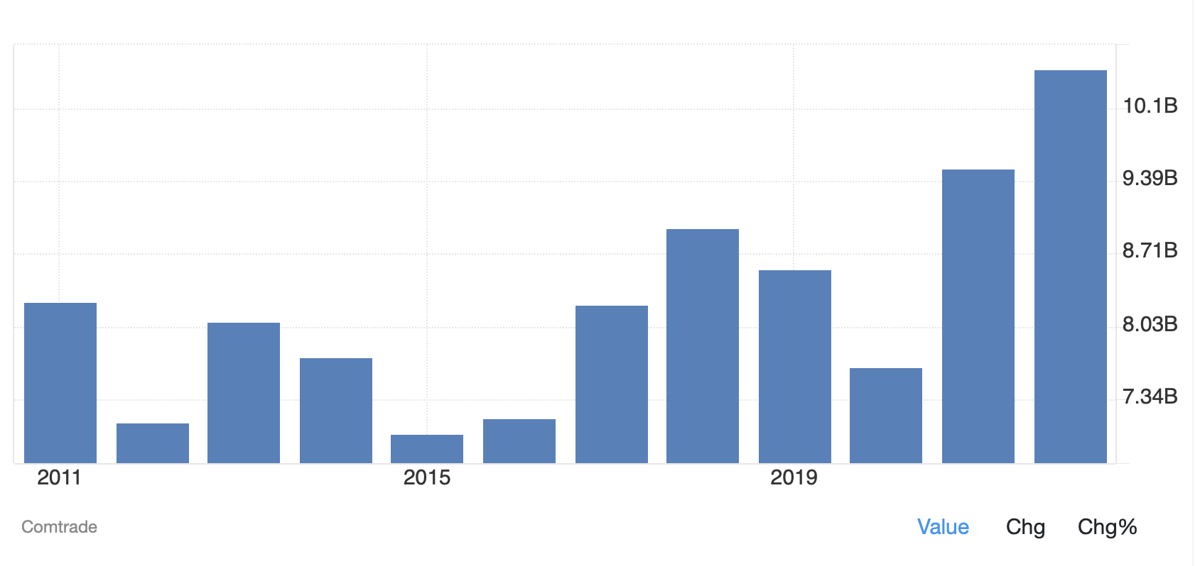

**Exporting cattle feed from India to Germany involves several steps and requirements. Here are some general guidelines to get started:**

1. **Obtain necessary licences and permits:** You will need to obtain an IEC (Import Export Code) from the Directorate General of Foreign Trade (DGFT) and register with the Agricultural and Processed Food Products Export Development Authority (APEDA) to export cattle feed from India.
2. **Ensure quality standards:** Your cattle feed must meet the quality standards set by the importing country as well as the Indian government. You may need to obtain certifications such as ISO 22000, FSSAI, and HACCP to demonstrate compliance with these standards.
3. **Find potential buyers:** You can search for potential buyers through trade directories, online marketplaces, or by attending trade fairs and exhibitions. It is important to establish a reliable and trustworthy relationship with your buyers.
4. **Secure shipping and logistics:** You will need to arrange for shipping and logistics, including packaging, transportation, and customs clearance.
5. **Comply with import regulations:** Each country has its own import regulations and requirements. You will need to ensure compliance with these regulations to avoid any legal issues.

It is important to consult with legal and business experts to ensure that you are following all necessary regulations and requirements.

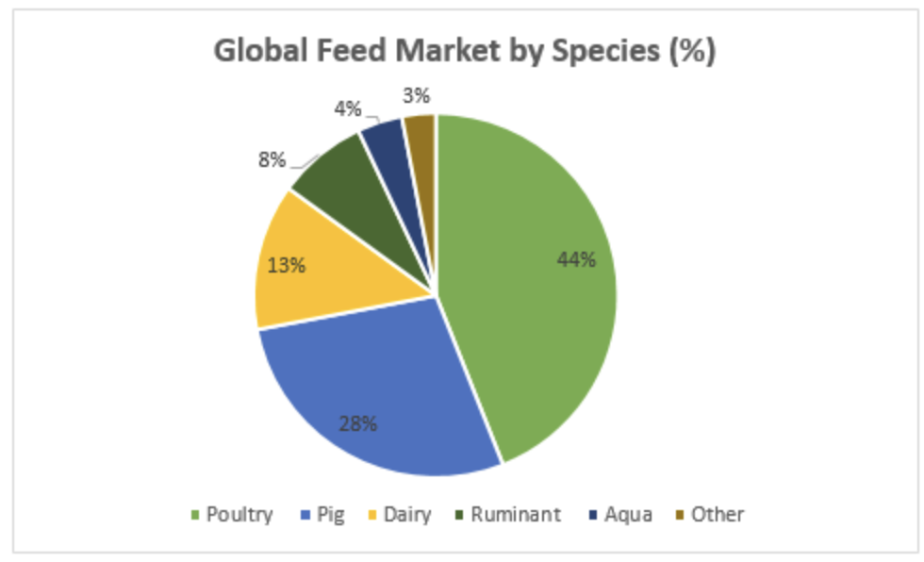

**Essentials for exporting to germany**

**You need to follow certain rules for exporting the items to Germany. You can follow the below steps:**

* Register your firm in registrar of industries in your state
* Apply for PAN card for your firm
* Since you are manufacturing products in India, you should have ‘FSSAI’ certification.
* ISO certification
* Open a bank account in nationalised bank having foreign exchange facility
* Apply for IEC code
* Based on the products you can join APEDA (Agricultural & Processed food products export development authority), Spices board and FIEO (Federation of Indian Export organisations)
* Get your product samples certificated in the laboratories authorised by above organisations.
* Finally check with the above organisations for any additional compliances to be followed.
* With this you are ready to export your goods to Germany.
* All these steps may seem to be long. But If you catch hold of some consultancies you can complete them in 2–3 months.

# **Pricing Strategy for Bansal & Company**

### 

### **Exercise purchasing power:**It is a business axiom that if you want lower prices you have to buy more or buy for a longer period of time. It makes sense to assume that increasing purchasing power (either increasing the volume per transaction or the duration of a purchasing contract) lowers prices per unit of weight.

### **Buy new feeders or fix the ones you have:**If approximately 25 percent of feed is wasted through poor management of feeders, feed and animals, it is a golden opportunity now to resolve this chronic issue by training personnel, fixing feeders and reallocating feeders

### **Cull out additives based on return on investment:** Using the right additives for each farm should be the work of a qualified nutritionist. Additives should be evaluated based on return on investment. Usually, additives that improve growth below 4-5 percent are difficult to justify during hard times.

### **Reconsider pelletting:** Pelleted feed is most likely to improve feed/gain ratio by 5 to 15 percent depending on diet nutrient composition, ingredients used and, of course, the species and weight class of the animals.

### **Seek out alternative cereals now:**Usually this is the first solution that comes to mind when cereal prices go up. But, unless you lock in a large quantity of such alternatives before the market adjusts, it is highly unlikely such ingredients will remain competitive for long.

# 

# 

# **Marketing Strategies For Bansal & Co.**

* ETRH system better known as the exclusive trade right holder, under this system the company appoints domestic and international Exclusive Trade Right Holders (Sole Proprietor / Partnership Firm, Company or Business Group) to whom the product marketing rights are endorsed on attestation of trade MOU by both the parties
* An ETRH is the one who owns the brand ownership and marketing rights of the product line in his area of activity
* According to the integrated product movement pattern, these finished product is transferred from the manufacturer to ETRH only
* In this case, the ETRH possesses an exclusive monopoly in product marketing and pricing perspective
* CORPORATE TIE UPS: are done effectively to encourage global and domestic corporate tie-ups. Under this scheme, we make channel partners who market our products in their areas. This way we are able to cover vast areas in different regions.
* These channel partners can refill the product in their TradeMark and get a commission on the basis of a fixed minimum purchase package
* The agreement is signed as per the mutual agreement of both parties

# **SWOT**

**Objective:** To identify Bansal & Company Strengths, Weaknesses, Opportunities, and Threats.

**Strength:**

* Brand Name
* Strong investment capacity and financial position
* ﻿﻿Skilled employee
* ﻿﻿More product range in product line.
* ﻿﻿Cost Advantage

**Weakness:**

* ﻿﻿Lack of R&D investment
* ﻿﻿Focus on Produc

**Opportunity:**

* ﻿﻿Acquisitions
* Emerging markets and expansion abroad
* Product and services expansion

**Threats:**

* ﻿﻿Lower cost of competitors product
* ﻿﻿Maturing products
* ﻿﻿Product substitution
* ﻿﻿Fluctuation in Animal feed Prices

## **Types of Export Risks**

### **Political Risks:** Exporters can face significant political risks when doing business in various countries. Some of these risks are established and well known while others can arise quickly and unexpectedly. A new election, sanctions or pressure from other countries’ governments, and civil unrest can all rapidly change a political situation. In general, the more stable a country’s business, financial and social systems are, the less political risk that country represents.

### **Legal Risks:** Laws and regulations vary around the world. What is common practice in one country may not be so in another. As a result, exporting companies could face legal issues related to a number of areas of the business, including customs, contracts, currency, and the liability and intellectual property rights involved with the products they sell.

### **Credit & Financial Risk:** When doing business internationally, the risk of nonpayment or default by customers is one of the key issues exporters must deal with. Indeed, export credit risk is among the most significant financial risks a company can face. Getting a delinquent customer to pay is difficult even when that customer is down the street. It can be exponentially more difficult when that customer is in another country.

### **Quality Risk:** Once goods are shipped, a customer may register complaints about the quality of those products. This could be a genuine objection based on the buyer’s specific requirements and expectations. It could also be a way for the buyer to gain leverage and negotiate a discount on the shipped products after the fact.

### **Language and Cultural Risk:** Doing business with importers and customers in another country requires a certain amount of trust. Differences in language, culture, religion and many other aspects of life require careful handling. For example, when exporters and their customers speak different languages, important details and nuances can get lost in translation.

### **Transportation and Logistics Risk:** Making an export sale is just the beginning of the process. The sold goods now need to be promptly and safely shipped to the customer. This is where exporters can encounter a range of transportation and logistics risks, which can vary based on the goods being shipped and the requirements to do so. Some goods require refrigeration, must not be exposed to excessive heat or cold, or have an expiration date. Other goods are extremely fragile, require careful handling or must be assembled before delivery to the customer. All shipments must be tracked. If something goes wrong, the buyer may try to negotiate a price reduction or reject the shipment altogether.

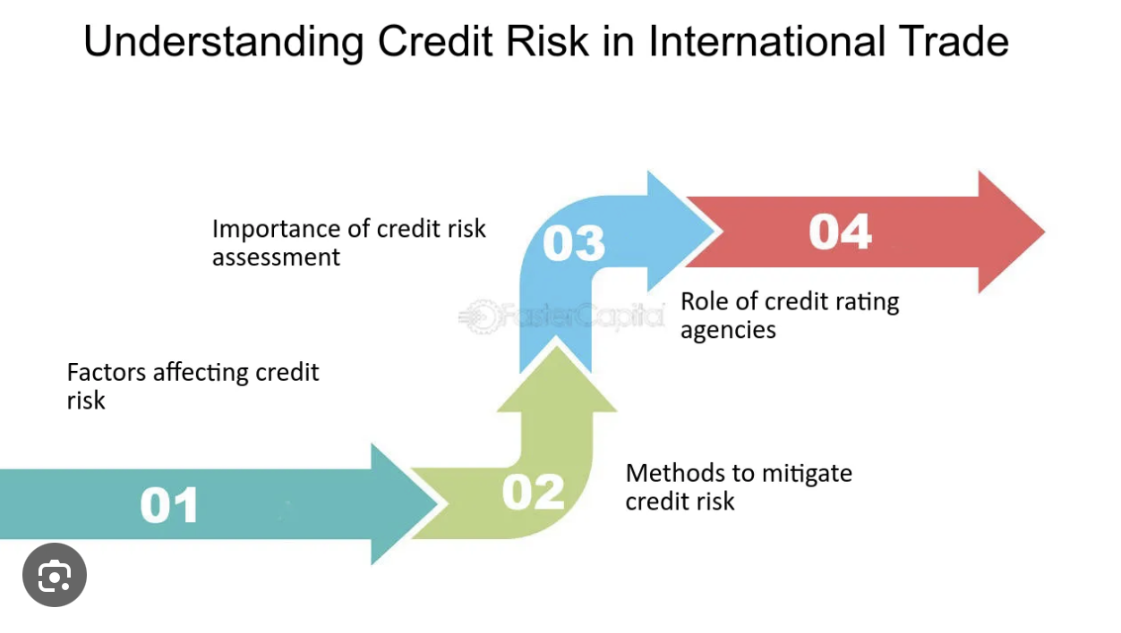

**Export Risk Mitigation**

* Direct Credit: Export Credit Agencies support exports through the provision of direct credits to either the importer or the exporter.
* Importer: a buyer credit is provided to the importer to purchase goods.
* Exporter: makes a deferred payment sale; insurance is used to protect the seller or bank.

**Guarantees**

* Bid bond (tender guarantee): protects against exporter’s unrealistic bid or failure to execute the contract after winning the bid.
* Performance bond: guarantees exporter’s performance after a contract is signed.
* Advance payment guarantee (letter of indemnity): in the case where an importer advances funds, guarantees a refund if exporter does not perform.
* Standby letter of credit: issuing bank promises to pay exporter on behalf of importer.

**Insurance**

* Transportation insurance: Covers goods during transport; degree of coverage varies.
* Credit Insurance: Protects against buyer insolvency or protracted defaults and/or political risks.
* Seller non-compliance (credit insurance): Covers advance payment risk.
* Foreign exchange risk insurance: Provides a hedge against foreign exchange risk.

**Hedging**

**Instruments used to Hedge Price Risk**

* Stabilisation programs and funds.
* Timing of purchase/sale.
* Fixed price long-term contracts.
* Forward contracts.
* Swaps

**When deciding whether to obtain insurance coverage for specific export risks,**

it is important to evaluate each risk and compare the cost of insurance with the potential benefits of doing so. In some cases, having insurance coverage for a specific risk provides not only protection but helps nurture the confidence necessary to expand and diversify the business.

* Export credit insurance provides protection against customer payment default and, often, against unpaid invoices caused by non-credit risks, such as political events.
* Political risk insurance can protect against loss caused by political events and turmoil.
* Transportation and logistics coverage can cover losses caused by problems and delays getting products to customers in the importing country.

**References:**

* [**https://www.slideshare.net/pankajbhaisare/marketing-plan-of-animal-feed-summerkool**](https://www.slideshare.net/pankajbhaisare/marketing-plan-of-animal-feed-summerkool)
* [**https://commerce.gov.in/trade-statistics/**](https://commerce.gov.in/trade-statistics/)
* [**https://www.mordorintelligence.com/industry-reports/germany-compound-feed-market**](https://www.mordorintelligence.com/industry-reports/germany-compound-feed-market)
* [**https://nijhofwassink.com/feed-logistics/animal-feed-distribution**](https://nijhofwassink.com/feed-logistics/animal-feed-distribution)
* [**https://tradestat.commerce.gov.in/eidb/default.asp**](https://tradestat.commerce.gov.in/eidb/default.asp)
* [**https://www.linkedin.com/pulse/germany-animal-feed-organic-trace-minerals-market-latest-z1pif/**](https://www.linkedin.com/pulse/germany-animal-feed-organic-trace-minerals-market-latest-z1pif/)
* [**https://tradingeconomics.com/india/exports/germanyhttps://www.eximguru.com/exim/guides/how-to-export/ch_14_export_risks_management.aspx**](https://tradingeconomics.com/india/exports/germanyhttps://www.eximguru.com/exim/guides/how-to-export/ch_14_export_risks_management.aspx)
* [**https://www.volza.com/p/cattle-feed/export/export-from-india/**](https://www.volza.com/p/cattle-feed/export/export-from-india/)
* [**https://www.allianz-trade.com/en_US/insights/export-risk-management.html**](https://www.allianz-trade.com/en_US/insights/export-risk-management.html)
* [**https://www.quora.com/How-can-we-start-export-our-produced-quality-cattle-feed-to-other-countries-from-India**](https://www.quora.com/How-can-we-start-export-our-produced-quality-cattle-feed-to-other-countries-from-India)
* [**https://commerce.gov.in/**](https://commerce.gov.in/)
* [**https://dof.gov.in/sites/default/files/2020-08/GuidelinesforexportrevisedApril2016_1.pdf**](https://dof.gov.in/sites/default/files/2020-08/GuidelinesforexportrevisedApril2016_1.pdf)
* [**https://economictimes.indiatimes.com/small-biz/trade/exports/insights/feeding-the-worlds-livestock-how-india-may-have-found-an-export-jackpot/articleshow/106532760.cms?from=mdr**](https://economictimes.indiatimes.com/small-biz/trade/exports/insights/feeding-the-worlds-livestock-how-india-may-have-found-an-export-jackpot/articleshow/106532760.cms?from=mdr)
* [**https://apeda.gov.in/apedawebsite/SubHead_Products/Prepared_Animal_Feeder.htm**](https://apeda.gov.in/apedawebsite/SubHead_Products/Prepared_Animal_Feeder.htm)
* [**https://apeda.gov.in/apedawebsite/organic/Organic_Products.htm**](https://apeda.gov.in/apedawebsite/organic/Organic_Products.htm)
* [**https://agriexchange.apeda.gov.in/IR_Standards/Import_Regulation/IndiasFSSAIAuthorizesaSixMonthExtensionforCompliancewiththeCommercialFeedsandFeedMaterialsStandardstoSelectIndustryStakeholdersNewDelhiIndia07082021.pdf**](https://agriexchange.apeda.gov.in/IR_Standards/Import_Regulation/IndiasFSSAIAuthorizesaSixMonthExtensionforCompliancewiththeCommercialFeedsandFeedMaterialsStandardstoSelectIndustryStakeholdersNewDelhiIndia07082021.pdf)